**Week 5 Visualizations Activity**

**Name: Dhairya Patel**

**1.**  Here, Every year in mid range of birthrate was lower compared to in winter and summer.

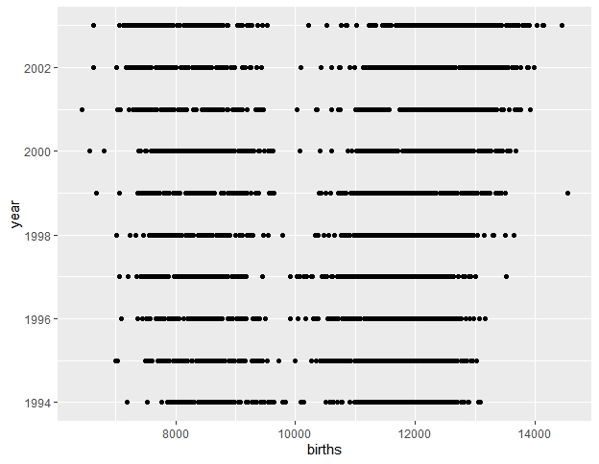

2. In this graph from 1993 to 2003, birth rate in US drastically increased in 1995 qbd then in 2003, reaons are not mentioned but that’s what we can visualize from this data.

